TEMPLE UNIVERSITY


Office of the Vice President for Research Institutional Biosafety Committee

STANDARD OPERATING PROCEDURE SOP# 2.0 BIOSAFETY LEVEL 2 (BSL2) PROCEDURES

BSL2 procedures: _ _ _ _

- Purpose

This standard operating procedure (SOP) describes the safe BSL2 procedures.

- Approvals

All research using BSL2 procedures must have IBC and IACUC (if working with animals) approvals prior to initiation of any research work.

- Trainings

Principal Investigator is responsible to train all researchers, staff, and animal care providers on all aspects of this SOP.

- Security

  - The laboratory supervisor must enforce the institutional policies that control access to the laboratory performing BSL2 procedures.

  - Access to the animal room is limited. Only those persons required for program or support purposes are authorized to enter the BSL2 animal facility and the areas where infectious materials and/or animals are housed or manipulated.

  - Escort the service workers (facilities engineer or BSC certifier), regulatory (OSHA, PaDEP, DOT, USDA, AAALAC), EHRS, IACUC inspectors at all times to the BSL2 room for services or inspection.

- Signage

  - Post agent summary, biohazard signage, and the agent’s name on the door to the room when performing BSL2 procedures. Room(s)

  - Post a biohazard symbol and agent’s name to the incubators, -80C freezers, and animal cages when storing BSL2 procedural agents. Room(s): _

  - Remove agent summary, biosafety signage and agent’s name from the door to the room when the agent is no longer present in the room.

- Safety Equipment

  - Biosafety Cabinet (BSC)

    - Certify the BSC annually by outside vendor to ensure continued, proper operation. Room(s):
_

    - Place two traps containing 10% bleach solution and a HEPA filter to protect the house vacuum line system from the backflow contamination of a BSL2 agent.

  - Used sharps (needles, syringes, tips, pipettes, and any sharps objects) must be carefully placed in conveniently located puncture-resistant sharps containers. Do not recap needles!

  - Autoclave

    - Place a biological indicator (BI) inside the autoclave along with the materials to be autoclaved for ensuring the effectiveness of the autoclave cycles once every week or once every 40 hours of operations. Records of the BI testing must be readily available.

  - Emergency eyewash must be readily available.

    - Check the eyewash station weekly. The facilities management check the eyewash station annually. Records of the weekly check must be readily available. Eyewash location: Room
_ .

- Personal Protective Equipment (PPE)

  - PPE

    - PPE for in vitro work in the laboratory are lab coat, goggle, and gloves for working with BSL2 procedures.

    - PPE for animal work are disposable gown, hair cover, mask, shoe covers, and gloves for animal work. PPE must be available for working with BSL2 animal procedures.

      - PPE donning procedure at the animal facility entrance

        - Don the disposable gown, hair cover, mask, shoe covers, and gloves before entering the BSL2 room.
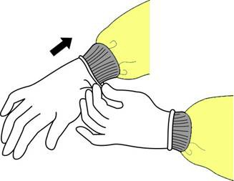

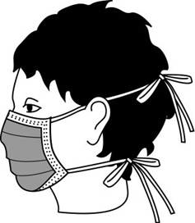

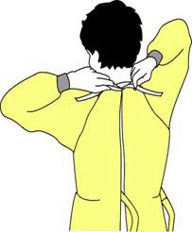

Gown ties in back Mask secures Gloves extend
on head over gown cuffs

        - Gloves should frequently be wetted with disinfectant and should be changed when contaminated or torn.

      - PPE doffing procedure at the animal facility exit area.

        - Doff the hair cover, mask, shoe covers.

Untie the bottom, then top Remove from face and discard
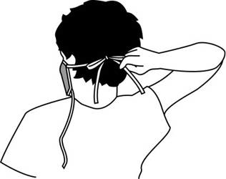

        - Doff the disposable gown

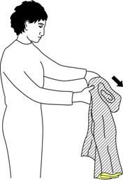

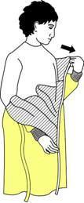



Unfasten ties Peel gown away from Turn contaminated outside
neck and shoulder toward the inside and roll into a bundle

        - Doff the gloves
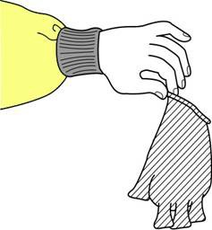

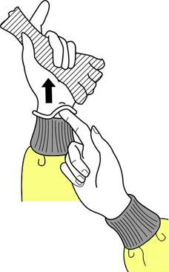

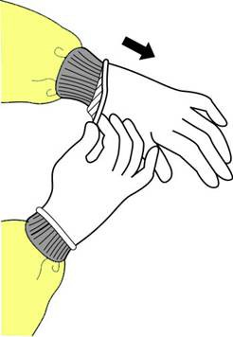

Peel away from hand | Slide ungloved finger | Create a bag from both gloves
Turing gloves inside-out | Peel off from insdie | Discard in a red bag

- Dispose All the PPE in a red bag.

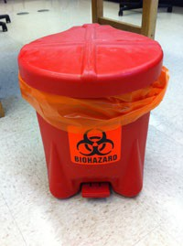 Solid container required to have a lined red bag, a lid, and a biohazard symbol.
- Persons must wash their hands after working with BSL2 materials and before leaving the laboratory.

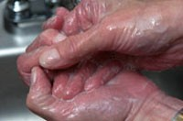

- Decontamination

Use 10% bleach or Quatricide®PV-15 solution to wipe down equipment and work surfaces for decontamination before and after performing BSL2 procedures.

- Animal Microisolator Cage Changing and Decontamination Procedures (This section only applies for performing BSL2 procedures in animal studies, if using disposable cages skip items 1-3 and complete item 4 below)

  - Place the soiled microisolator cages in a BSC. Room(s):

  - Soiled bedding

- Empty soiled bedding material into double red biohazard bags within the BSC. Securely seal the bag and spray Quatricide®PV-15 solution to exterior of the outer bag before removal from BSC.

- Place the red bags in the red bin located in the ULAR soiled side cage wash area.

- Soiled bedding material will be picked up by a certified vendor and decontaminated off site.

  - Soiled caging material and Hydropac™ water pouches

- Place empty caging material (cages, diet trays, Lifespan™ platforms, filter tops) in double autoclave bags within the BSC. Securely seal the autoclave bags and spray Quatricide®PV-15 to the exterior of the outer bag before removal from the BSC.

- Place used Hydropac™ water pouches and lixit valves in separate double autoclave bags within the BSC. Securly seal the autoclave bags. Label the outer bag as “Liquid Cycle”. Spray Quatricide®PV-15 to the exterior of the outer bag before removal from the BSC.

- Move all bags to be autoclaved to the ULAR soiled side cage wash for autoclaving.

- ULAR staff will autoclave the caging material. Processed autoclaved caging material will be sent through the cage washer and auotclaved water pouches and valves will be discarded.

ULAR will bag bedding/caging: yes no
Laboratory staff will bag bedding/caging: yes _ no _

  - Place the empty BSL2 disposable cages inside a BSC. Wipe the outer disposable cage surfaces with Quatricide® PV-15 solution and place the disposable cages inside a red bag. Securely seal the bag and spray Quatricide® PV-15 solution to on the exterior of the bag before removal from BSC. Red bagged waste will be disposed of by ULAR staff through the waste management system.
Room(s): _

- Biological Waste Management

  - For laboratory in vitro work, place all solid waste in a red bag to be picked up by a certified vendor. Place all sharps items in a sharps container to be picked up by certified vendor. Chemically disinfect (10% bleach, 10 minutes contact time) all infectious liquid waste before release to sanitary sewer.

  - Place animal carcasses in a red biohazard bag in a BSC. Securely seal the bag and spray Quatricide®PV-15 solution to exterior of the bag before removal from BSC. Place the carcasses in the ULAR carcass freezer (Room: ).

- Spill Management

  - Small Spill

    - Don the lab coat, goggles, and gloves in the laboratory or follow the PPE donning procedure in Section G, when cleaning a small spill in the lab area or animal facilities.

    - Contain the small spill by covering with absorbent pads or paper towel.

    - Disinfect the spill by adding 10% bleach and 10 minutes contact time.

    - Carefully remove potentially contaminated protective clothing as mentioned in the section of PPE doffing procedure if there is a splash in the protective equipment.

    - Dispose all solid wastes generated from spill in a red bag. Place all sharps items in a sharp container.

- Large Spill (any spill involving concentrated BSL2 agents, more than 100 ml of BSL2 agent container liquid, aerosol generated incident, and incident involving the centrifuge)

  - Notify individual in the room to evacuate.

  - Leave the room and notify PI and EHRS.

  - Carefully remove potentially contaminated protective clothing based on the PPE doffing procedure listed in section G if the PPE is contaminated.

  - Place the contaminated PPE in a red bag.

  - Do not enter the room until clearance by the EHRS.

  - EHRS will respond the large spill according to the following procedure.

    - Allow the aerosolized particles from the large spill to settle for 2 hours.

    - Post a signage of “DO NOT ENTER” should be posted at the entrance of BSL2 procedural room.

    - Don the disposable gown, face shield and gloves.

    - Prepare a large volume of a 10% bleach solution.

    - Spray all surfaces and items with 10% bleach including ceilings, walls, bench surfaces, cabinets and floors. Allow 10 minutes contact time. Then, spray everything with 70% isopropyl alcohol.

    - Remove PPE and place in a red bag and seal the waste bag. Sharps items are disposed of in a sharps container.

- Emergency Response

  - Wash the affected areas with copious amounts of lukewarm water in the event of personnel exposure such as eye, skin, mucous membranes or body fluids contact when performing a BSL2 procedure.

  - Report to PI and seek immediate medical evaluation if there is personnel exposure

    - During office hour
      - Health Science Center: Go to the Occupational Health Department, M-F, 8:00 AM to 5:00 PM.
      - Main Campus: Go to Employee Health Services, M-F, 8:30 am - noon; 1 pm - 4:40 pm.

    - After office hour
      - After 5 PM, go to Temple University Hospital Emergency Department.

  - Principal Investigator must immediately report the incident to the EHRS.

- Date of the SOP #2.0 training for lab workers and animal care providers:

Name (please print) | Signature | TUID Number | Department | Position / Title

